**Type 2 Liverpool Ringing Simulator**

04 – Configuring Beltower Guide

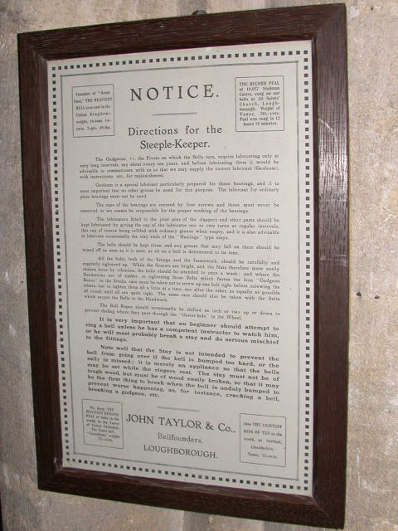

Author: Andrew Instone-Cowie

Date: 18 August 2020

Version: 1.2

Contents

Index of Figures 2

Document History 3

Licence 3

Documentation Map 4

About This Guide 5

First Steps 5

Next Steps 5

Beltower Copyrights & Licensing 6

Sensors Configuration 6

Delay Timer Calibration 12

Using Multiple PCs 13

Second PC Module & Basic Serial Splitter Module 13

Configuring the Interface 13

# Index of Figures

Figure 1 – Documentation Map 4

Figure 2 – Beltower – Mode Selection 6

Figure 3 – Beltower – Settings Menu 7

Figure 4 – Beltower – Serial Input Mode 7

Figure 5 – Beltower – Sensor Settings 8

Figure 6 – Beltower – Editing Delays 8

Figure 7 – Beltower – Sensor Delays 9

Figure 8 – Beltower – Basic Mode 10

Figure 9 – Beltower – Basic Mode Options 10

Figure 10 – Beltower – Advanced Mode Options 11

Figure 11 – Beltower – Ring Options (Bell Sensors) 13

# 

# Document History

|  |  |  |  |
| --- | --- | --- | --- |
| **Version** | **Author** | **Date** | **Changes** |
| 0.1 | A J Instone-Cowie | 10/09/2018 | First Draft. |
| 1.0 | A J Instone-Cowie | 03/08/2019 | First Release. |
| 1.1 | A J Instone-Cowie | 01/10/2019 | Multi-PC Options. |
| 1.1 | A J Instone-Cowie | 18/08/2020 | Minor update. |

*Copyright ©2018-20 Andrew Instone-Cowie.*

*Cover photograph: “Directions for the Steeple-Keeper”. © 2008 Keith Edkins*

*[CC BY-SA 2.0 (<http://creativecommons.org/licenses/by-sa/2.0>)], via Wikimedia Commons*

# Licence

**

*This work is licensed under a Creative Commons Attribution-ShareAlike 4.0 International License.[1]*

*Unless otherwise separately undertaken by the Licensor, to the extent possible, the Licensor offers the Licensed Material as-is and as-available, and makes no representations or warranties of any kind concerning the Licensed Material, whether express, implied, statutory, or other. This includes, without limitation, warranties of title, merchantability, fitness for a particular purpose, non-infringement, absence of latent or other defects, accuracy, or the presence or absence of errors, whether or not known or discoverable. Where disclaimers of warranties are not allowed in full or in part, this disclaimer may not apply to You.*

*To the extent possible, in no event will the Licensor be liable to You on any legal theory (including, without limitation, negligence) or otherwise for any direct, special, indirect, incidental, consequential, punitive, exemplary, or other losses, costs, expenses, or damages arising out of this Public License or use of the Licensed Material, even if the Licensor has been advised of the possibility of such losses, costs, expenses, or damages. Where a limitation of liability is not allowed in full or in part, this limitation may not apply to You.*

# Documentation Map

Figure 1 – Documentation Map

# About This Guide

The Type 2 Liverpool Ringing Simulator allows sensors, attached to one or more real tower bells or teaching dumb bells, to be connected to a computer Simulator Software Package such as Abel[2], Beltower[3] or Virtual Belfry[4]. This allows you to extend and augment the teaching and practice opportunities in your tower.

This brief ***Configuring Beltower Guide*** shows you how to configure the Beltower Simulator Software Package to work with the Type 2 Liverpool Ringing Simulator.

Other project guides are available for the Abel and Virtual Belfry packages.

In view of the restrictions on ringing arising from COVID-19, there are currently no plans for further development of the Liverpool Simulator.

## First Steps

This guide begins from the point that you have completed building and installing your Type 2 Liverpool Simulator hardware, and are now ready to configure Beltower to work with the simulator.

For guidance on building and installing the Type 2 Liverpool Simulator, please refer to the ***Build & Installation Guide***. For detailed technical information, see also the ***Technical Reference Guide***.

If you want to use multiple PCs concurrently, please refer the ***Multi-PC Guide*** for information on building either the Second PC module or the Basic Serial Splitter module. The Second PC module allows two PCs to be used concurrently, the Basic Serial Splitter up to a maximum of 16.

## Next Steps

This is not a detailed guide to using Beltower. Please refer to the Beltower documentation and help for more information on the usage and configuration of the application.

This is also not a guide to using a simulator in teaching and practice. For guidance in this area the ART[5] publication ***Teaching with Simulators*** is recommended, available from the ART shop[6].

# Beltower Copyrights & Licensing

Beltower is a copyright software product ©D. J. Ballard, made available under the Beltower Licence Agreement included with the software.

Please ensure your copy of Beltower is properly licensed.

Beltower can be ordered from <http://www.beltower.co.uk/>.

# Sensors Configuration

Configuration of the Beltower Simulator Software Package to use the Simulator Interface should also only need to be done once. All settings are saved in the Beltower configuration file. This example is based on Beltower 2017 (12.35).

To configure Beltower to use the Simulator Interface, carry out the following steps. This manual described the minimum necessary to configure Beltower to use the Simulator Interface, for full details on the overall configuration and features of Beltower please refer to the product documentation.

* Start Beltower on the Simulator PC, select Advanced Mode.

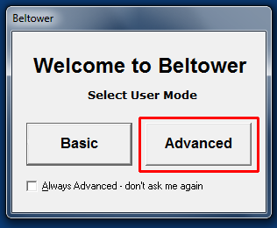

Figure 2 – Beltower – Mode Selection

* From the *Settings…* menu select *Sensors* (or press F12).

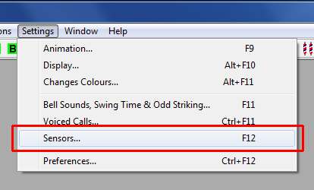

Figure 3 – Beltower – Settings Menu

* In the *Input Mode* dropdown, select *Serial interface*, and in the *Input* dropdown select the correct serial interface COM port number for the Simulator Interface. Note that Beltower requires the serial COM port number to be between 1 and 32 (for versions prior to Beltower 2016 the upper limit was 8). Refer to the ***Technical Reference Guide*** for instructions on reconfiguring port numbers.

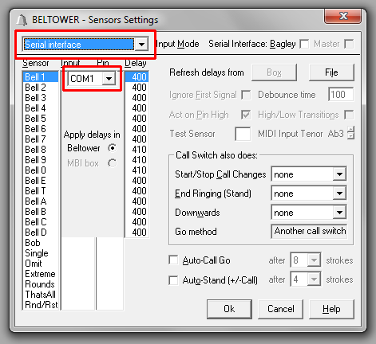

Figure 4 – Beltower – Serial Input Mode

* Ensure that the *Apply delays in Beltower* radio button is selected, and that both the *Bagley* and *Master* check boxes are not ticked.

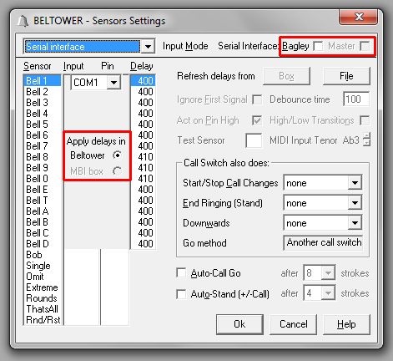

Figure 5 – Beltower – Sensor Settings

* Double-click each delay timer value to show the up and down buttons.

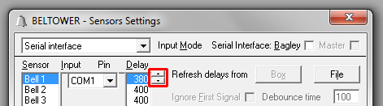

Figure 6 – Beltower – Editing Delays

* Set the delay for each bell to an appropriate value, so that the simulated bell sounds as closely as possible to the same time as the real bell (this is best done with the real bell un-silenced. Note that in Beltower the delay values are specified in 1/1000ths of a second (milliseconds), in increments of 10ms. Refer to the notes on Delay Time Calibration later in this guide.

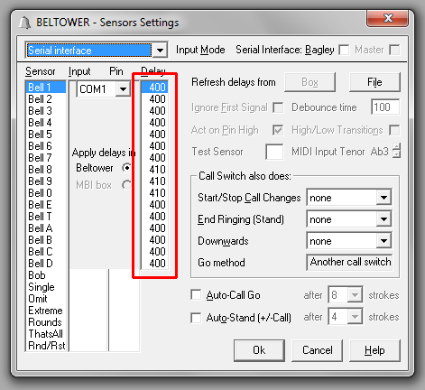

Figure 7 – Beltower – Sensor Delays

* Click *OK* in the *Sensor Settings* window to close the window.
* Save the new options by selecting *Save Selections* from the *File* menu. If the options have changed, Beltower will also prompt for this when the program is closed.
* Activating the sensor configuration is done in one of two different ways, depending on whether Beltower is being used in *Basic* or *Advanced* mode.
* In *Basic* mode, select one of the *Tower Bell Sensor(s)* options from the dropdown shown when the application starts.

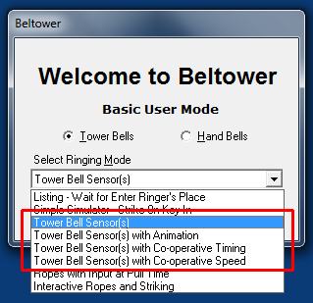

Figure 8 – Beltower – Basic Mode

* When Beltower is running in *Basic* mode, the sensor configuration can be activated by selecting *Ring Options…* from the *Options* menu (or press F8), then selecting *Tower Bell Sensor(s)* from the *Timing Options* dropdown and clicking the *Initialize* button.

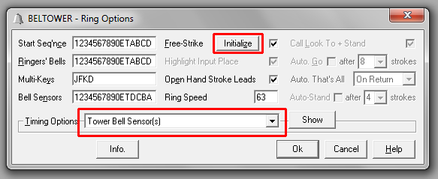

Figure 9 – Beltower – Basic Mode Options

* When Beltower is running in *Advanced* mode, the sensor configuration can be activated by selecting *Ring Options…* from the *Options* menu (or press F8), then checking the *External Sensors* radio button, and clicking the *Initialize* button.

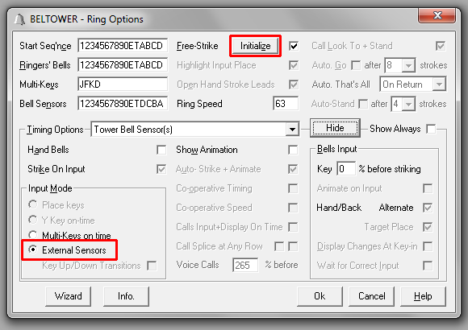

Figure 10 – Beltower – Advanced Mode Options

* Beltower should now be configured to use the Simulator Interface. Test each bell in turn and check that the simulated bells are correctly mapped to the real bells.

# Delay Timer Calibration

For accurate simulation of the real bells, the simulator requires that the delay timer for each bell is set so that the delay applied after Simulator Interface sends the strike signal to the Simulator (at exactly the point at which the real bell passes through bottom dead centre of its swing) results in the simulator sounding at the same time that the open bell would have struck. This delay time is specific to each bell, but for most bells is somewhere around 0.5s (or 500 milliseconds).

The simplest method of setting the timer values is to ring each bell open alongside the simulator.

* Start the Beltower on the Simulator PC.
* Ring each bell in turn, open, and compare the sound of the bell and the simulated sound from the simulator.
* If the real bell sounds before the simulator, reduce that bell’s delay timer value.
* If the simulator sounds before the real bell, increase that bell’s delay timer value.
* Repeat this process until the sound of the real bell and the sound from the simulator are as close to coincident as possible.
* Repeat for each of the other bells in turn.

Tip: A useful starting point for delay timer values is to measure the period of oscillation of the bell for small swings and set the timer to ¼ of that value. Then fine tune the value as described above.

# Using Multiple PCs

If you want to use multiple PCs concurrently, please refer the ***Multi-PC Guide*** for information on building either the Second PC module or the Basic Serial Splitter module. The Second PC module allows two PCs to be used concurrently, the Basic Serial Splitter up to a maximum of 16.

A Multi-PC configuration typically allows more than one ringer (with headphones) to use the simulator with a simulated band at the same time, each ringing a different physical bell.

## Second PC Module & Basic Serial Splitter Module

From the point of view of Beltower, all PCs connected using either the Second PC module or the Basic Serial Splitter module behave in a similar manner. All PCs receive all the sensor signals from the Simulator Interface module, all the time.

Each copy of Beltower must be configured to respond to the desired bell or bells and filter out the unwanted signals. This can be done by selecting the bell(s) required in the *Bell Sensors* field in the *Ring Options* dialogue.

Figure – Beltower – Ring Options (Bell Sensors)

## Configuring the Interface

When multiple PCs are connected, only one PC can be used to configure the Simulator Interface using a terminal emulator (as described in the ***Build & Installation Guide*** and the ***Multi-PC Guide***).

The PC used for Interface configuration depends on the hardware in use. This is covered in the ***Multi-PC Guide***.

1. <http://creativecommons.org/licenses/by-sa/4.0/>
2. <http://www.abelsim.co.uk/>
3. <http://www.beltower.co.uk/>
4. <http://www.belfryware.com/>
5. Association of Ringing Teachers
6. <http://ringingteachers.org/resource-centre/shop>